Fixed upper banner:
Logo Haifa University on the right
Logo NRU on the left
In between links:
- About us – dropdown menu: vision, team, directions, contact details.
- Facilities – dropdown menu: MRI, peripheral equipment, Helsinki& Insurance, wiki, data management
- Research – dropdown menu: ongoing research projects, publications, get involved.
- Education – dropdown menu: undergraduate, postgraduate, summer school
- Booking – link to the booking page
- Contact us – link to contact form
Change language (Hebrew, English, Arabic, Russian)

Fixed: Bottom banner,
links to:
- Directions
- Contact details
- booking page
- UH home page
- UH Research unit

Home Page (landing page- suggested design)
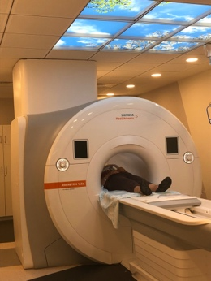 |  | 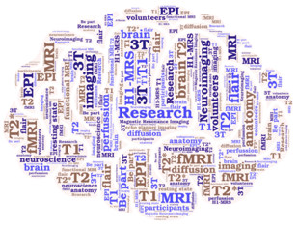 | 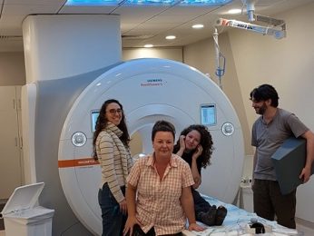 | Contact form
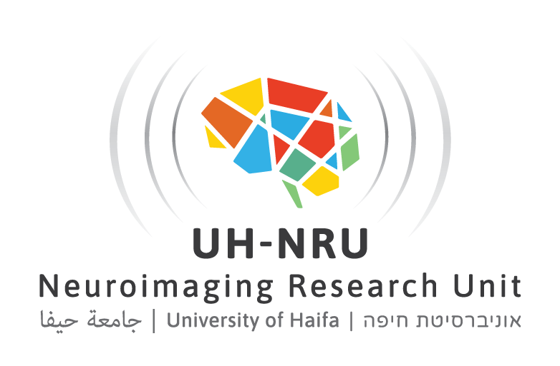 |  |  | 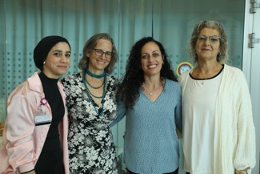 | Contact form
 |  |  | 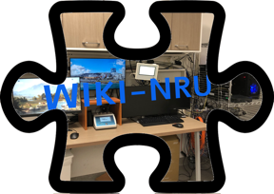 | Contact form

Overall sight map
Landing page
Side bar: contact us page
Links:
Picture - About us
Picture – Facilities
Picture – Research
Picture - Education
Picture – Booking
Picture – Wiki

About US
Vision – past, present, future
Team
Directions
Contact us
Facilities
Landing page - MRI
Cartoon – peripheral
Cartoon – data management

Banner:
ABOUT US

Vision:

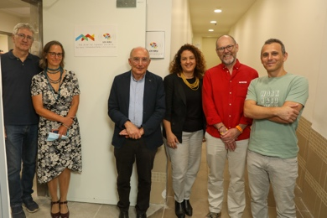 | University of Haifa Neuroimaging Research Unit (UH-NRU) was established in October 2022. The unit was funded by a grant awarded to Dr. Roee Admon, Dr. Avi Mendelson, and Professor Avi Karni from the Council for Higher Education and the Planning and Budgeting Committee. In collaboration with Rambam Health Care Campus, an MRI machine was installed within a newly renovated unit which includes dedicated space for research. | 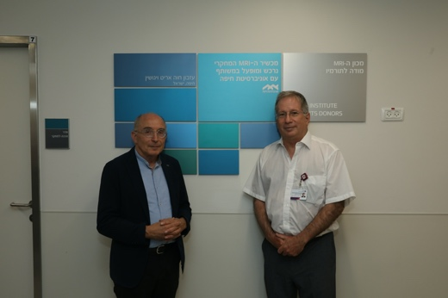
UH-NRU hosts a 3T MAGNETOM Vida Siemens MRI scanner and a wealth of peripheral equipment to deliver stimuli and record human physiological and behavioral responses. We are in the MRI unit of the Rambam Health Care Campus. | 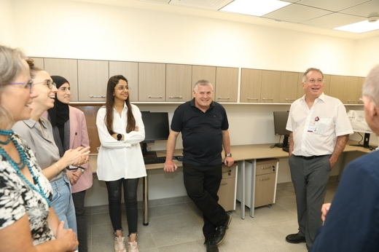
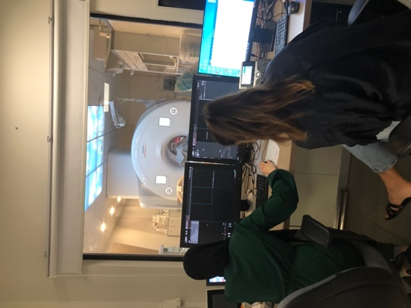 |  | In alignment with the University of Haifa's strategic plan, we strive to engage with the local community making a positive impact on the population in the north of Israel and beyond. We are committed to researching to improve humankind's well-being while protecting the environment.
movie
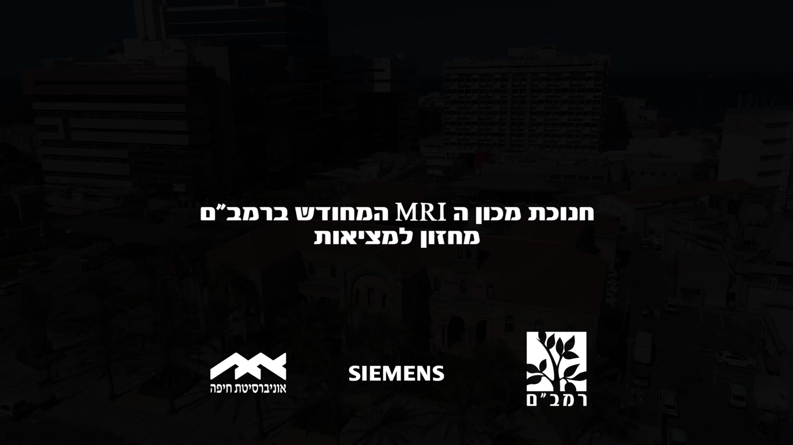

Team
ABOUT US
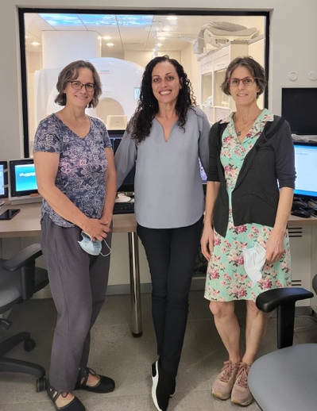 | Dr Pia Rotshtein  Director, UH-NRU  Dr Rotshtein was a faculty at the Centre for Human Brain Health, University of Birmingham, UK.  She is an expert in cognitive neuroscience, with specific experience in using imaging to answer cognitive questions. | 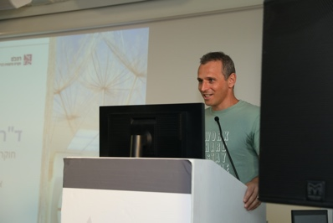
Dr Ayelet Eran  Director, MRI Unit, Rambam Health Care Campus (RMC)  Dr Eran is a neuroradiologist. She collaborates with us as a PI on most of our research projects.  Dr Anat Grinfeld  Head of Research & MRI safety, MRI Unit, RMC.  Dr Grinfeld is a biomedical engineer, with a wealth of experience in MRI and imaging. She collaborates with us on most of the research projects as co-PI.  Ms. Hannah Vakart  Head of MRI technician, MRI Unit, RMC | 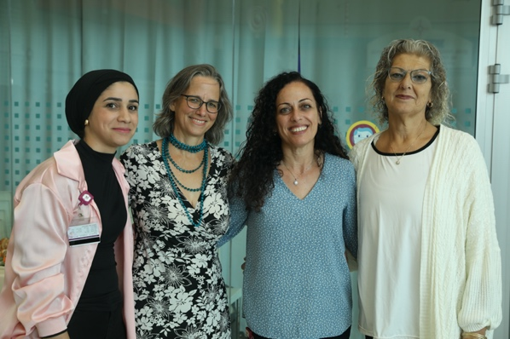 | Dr. Roee Admon  Academic Director  Dr Admon is an assistant professor at the University of Haifa. He was the main driver in realizing his dream to bring an MRI to University of Haifa.
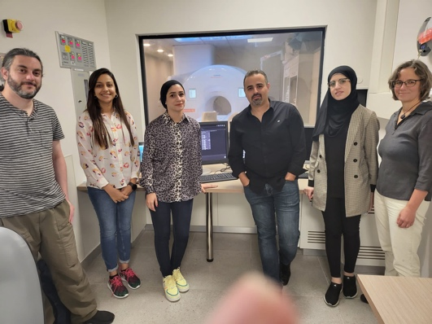 | Ms. Haneen Mattar  Research coordinator UH-NRU & MRI Unit, RMC.  Ms. Mattar is responsible on Helsinki submission and managing. She is also a scanner operator.  Ms Amaal Abbas Halila,  Administrative Manager, Research Council, University Haifa  Ms. Tehila Fridman,  Project Manager, Research Council, University Haifa | Dr. David Manor  Academic Adviser, UH-NRU & MRI Unit, RMC.  Dr Manor is a neuroscientist with specific expertise in MRI physics and cardio imaging. He is responsible on the implementing imaging protocols and on the peripheral equipment.  Mr Rani Bar-On  Experimenter builder and programming consultant.
Scanner operators:  Mr. Daneil Panitz  Mr. Panitz is also research fMRI analysis consultant.  Ms. Atheer Massarwe  Ms. Saffaa Masswara  Ms. Shir Hanuca  Ms. Galit Peysachov | 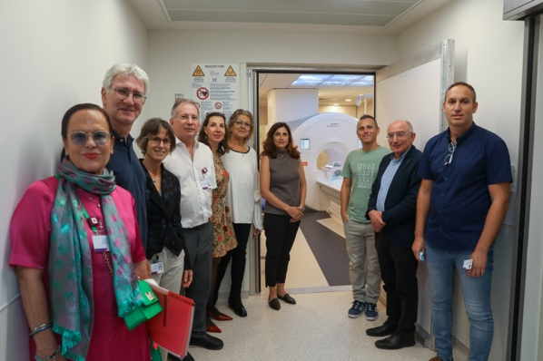

\\\\\\\\\\\\\\\\\\\\\\\\\\\\\\\\\\\\\\\\\\\\\\\\\\\\\\\\\\\\\\\\\\\\\\\\\\\\\\\\\\\\\\\
עוד לא סדרתי את המידע בטבלה מפה ומטה
How to find us?
We are in Rambam Health Care Campus,
MRI Unit,
Sami Offer Building, floor -1
HaAliya HaShniya St 8, Haifa

By Train, we are located 5 minutes’ walk from Bat Galim Train Station
By Bus, we are located 5 minutes’ walk from Bat Galim Bus Station
By Car,
HaAliya HaShniya St 8, Haifa

Facilities/

3T MAGNETOM VIDA MRI
UH-NRU hosts a MAGNETOM Vida 3T MRI scanner XA31, located at Rambam Medical Health Campus.

MAGNETOM Vida is the newest MR scanner from Siemens. It incorporates the technological advantages introduced by PRISMA (the popular model for research in the past 10 years) into a clinical-friendly setup.

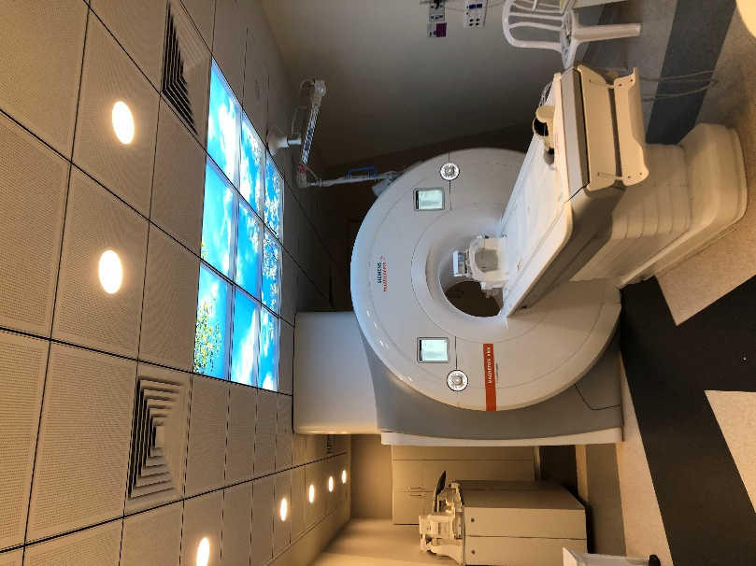
The MAGENTOM Vida is designed to go beyond Prisma by optimizing the protocol for individuals. For example, by tailoring the shimming to the scanned organ to reduce distortions and artefacts, maximizing comfortability for the patient (participant) by introducing a wider boar (the tunnel).

The MAGNETOM Vida is a whole-body scanner. UH-NRU includes coils and sequences to image all body parts. Specifically for the brain, we have two coils: 20 and 64 channels.

UH-NRU has a research agreement with Siemens, which means that we can develop and install sequences from other sites. We currently have installed the fMRI and DTI multiband sequence used by the Human Connectome Protocol and the H-MRS protocol from the University of Minnesota’s CMRR.

Facility/Peripheral equipment
Visual:
MR Compatible BOLDscreen 32 UHD - Cambridge Research System.
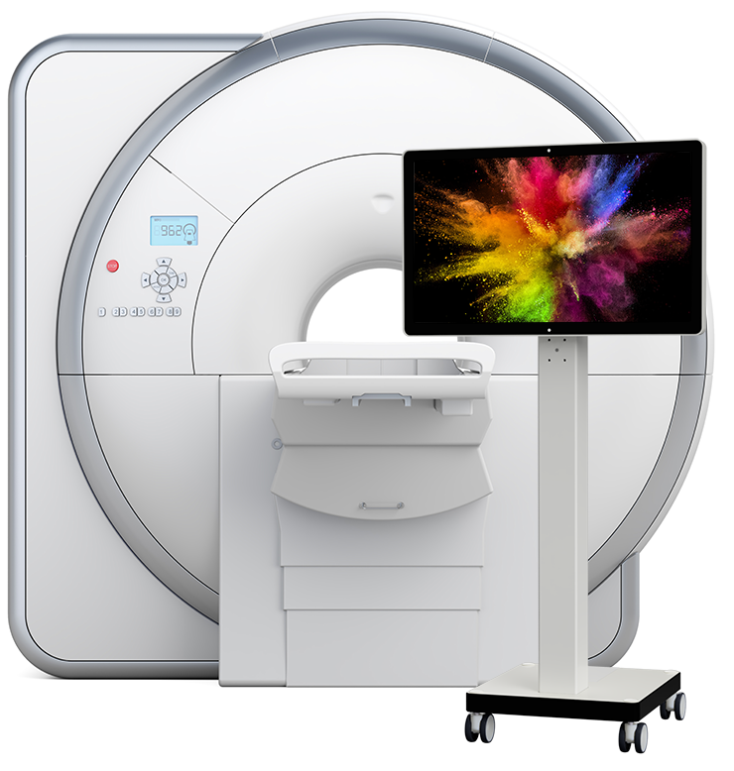
Auditory: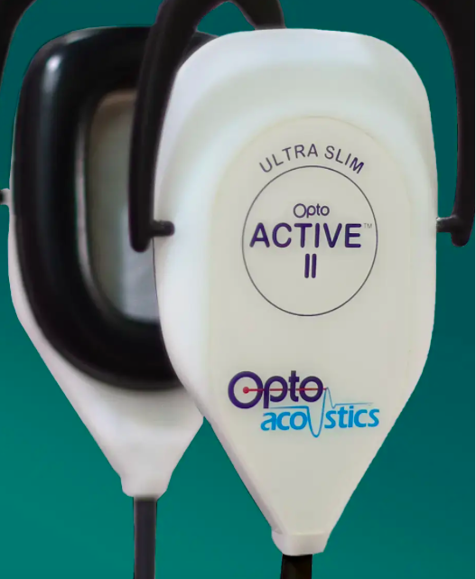
Optical MRI communication system - OptoAcoustic with active noise cancellation

Facility/Peripheral equipment
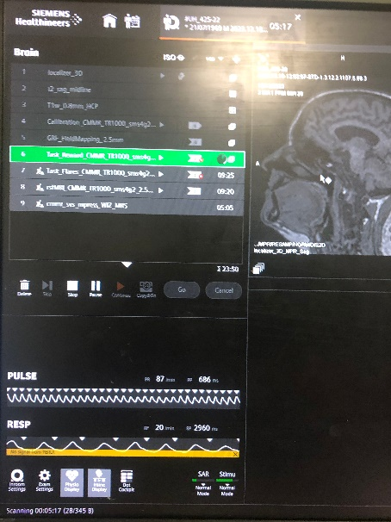
Siemens inbuilt physiological recordings:
- Heart rate using pulse oxygen saturation.
- Heart rate using MR-compatible ECG (EKG)
- Breathing

MR compatible BIOPACK MP160 + Acknowledge +Basic scripting, including:
- for Skin-conductance response, EDA/GSR– BPEDA100C-MRI
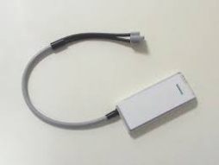
- for Temperature, BPSKT100C
- for Pressure, BPDA100C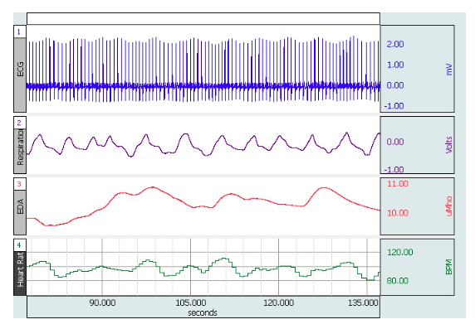

- for muscle activity, EMG system

/MR-compatible EyeLink 1000 plus from SR-Research for measuring eye movements and pupil dilation.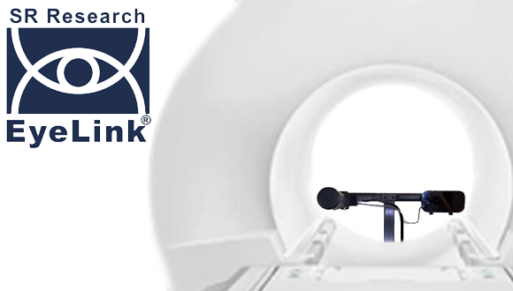

/MR-compatible in-bore video camera from MRC system for eye tracking and videoing of the face, hands, and other body parts. 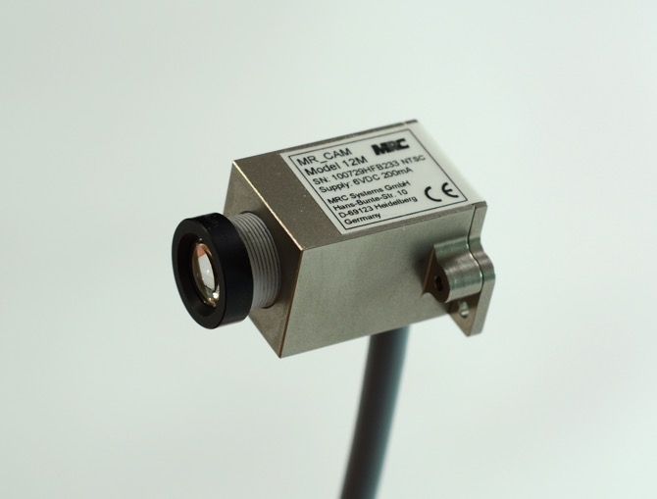

Facility/Peripheral equipment /Recording of behavioural responses
Selection of response boxes from Current Design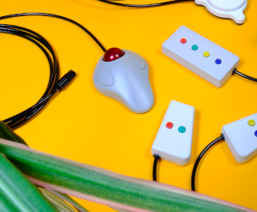

MR-compatible in-bore video camera from MRC system for eye tracking and videoing of the face, hands, and other body parts.

Facility/Data Management
Data Anonymization - the MR data is collected using pseudo-anonymization (The key linking the pseudo-anonymized data and the participants’ details is held by the principal investigator ). The pseudo-anonymized data is directly sent to a dedicated HIPA-protected cloud managed by the University of Haifa. Data from the peripheral equipment will also be sent to the same cloud folder. The data are organised using the BIDS (Brain Imaging Data Structure) format and transformed into project-specific folders. Researchers will need to download the data to analyse it. The data will be archived for 25 years.

Facility/Helsinki-Ethical approvals and insurance
In Israel, research involving scanning human participants with MRI requires ethical approval from a medical-led Helsinki committee. This is because MRI scanners are regulated by the Ministry of Health. Hence research in UH-NRU will require ethical approval from Rambam’s Helsinki committee. We would also require ethical approval from the researchers’ institution's ethical committee.

The Ministry of Health’s regulations require that research projects involving MRI will be led by a PI with medical qualifications (i.e. an MD doctor). By default, in UH-NRU, Dr. Ayelet Eran, who is the head of the MRI unit at Rambam Medical Care Campus will be the PI for our projects. Academic and industry-based researchers are defined as research sponsors.

We currently have an active Helsinki protocol to cover pilot studies with consenting adults (18+ years old).

An additional requirement of the MoH is that the sponsor will provide insurance coverage for the hospital in case of harm to research participants (up to $3 million). The University of Haifa bought insurance to cover its own research projects, for other academic institutes and industries please contact us.

UH-NRU has a dedicated research coordinator who will support the Helsinki application and liaise on the researchers' behalf with the Helsinki committee.

Facility/Scientific Support

UH-NRU has extensive expertise in Cognitive Neuroscience Research and can provide support and guidance for all study stages, starting from defining the research questions, designing the experimental protocol, analysing the data, and writing up for publications.
In addition, we have experts in MRI physics who can aid in designing and optimising sequences.
UH-NRU also plan to offer access to cloud-based computing resources (AZUR) where Neurodesk is installed to facilitate data analysis. Neurodesk platform offers a virtual window with access to the most used tools for brain imaging analysis.

Fcaility/Non-MR Testing facilities
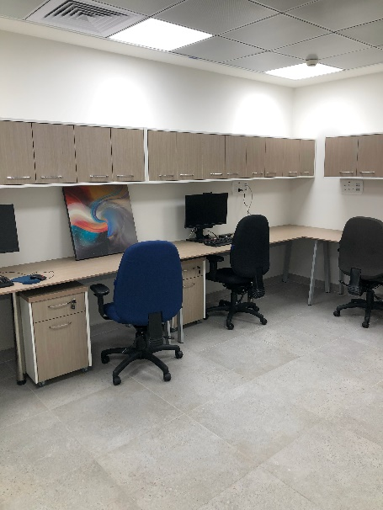
UH-NRU includes offices and rooms located in -1 floor, the main building of the Rambam Medical Care Campus.
- Research preparation room, which hosts a replica of the stimulus computer that is in the scanner control room.
- A testing/storage room that can be used for testing.
- A cubical for running experiments which also has a sink.
- A room with three computers that can be used for data analysis.
- Two additional offices that are used by staff, but can serve for private interviews, if needed.
- A freezer -24 degrees to temporarily store biological samples.

Research/research highlight

Creativity and the brain
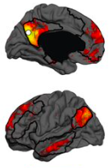
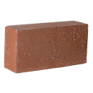
Professor Simone Shamay-Tsoory and colleagues combined resting-state fMRI, and direct current stimulation to show the involvement of the Default Mode Network in creative thinking. The default mode network is a set of midline cortical regions, which is more active when thoughts have no clear and specific external goal. Creative thinking was measured with the ‘Alternative Use Task’, where participants were asked to come up with as many as possible ways one can use a brick, for example. The researchers report that stronger coupling within the Default Mode Network was associated with creative ability. Interference of this network using electrical stimulation results in reduced creative fluency. Click here for the full paper.

Body ownership and the brain:
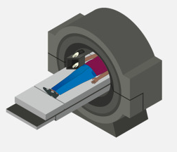
Professor Salomon and colleagues aimed to solve the misalignment puzzle of our awareness of our own body and the true sensations of it. The rubber hand illusion is a classic example, in which we subjectively feel a rubber hand to be part of our body. In this research, the authors used an fMRI to measure brain responses while participants experienced the rubber hand illusion. The authors report that the subjective feeling of the body is represented in a different network than the sensation of it. Click here for the full paper.

Predicting PTSD following trauma
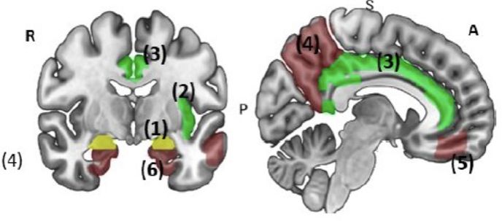
Dr Admon and colleagues offer a new imaging marker to predict the development of Post-Traumatic Stress Disorder (PTSD) following trauma. Following traumatic an event, some individuals develop PTSD. This is a debilitating condition with symptoms that include intrusion thoughts, heightened vigilance, and alert response. The author reports that a pattern of spontaneous coupling between different brain regions, measured a month after the trauma can predict who will develop the chronic PTSD condition. Click here for the full paper

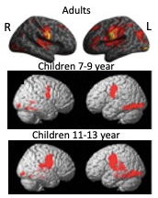
Reading in Children
Professor Bitan and colleagues investigated the neurodevelopment of reading in children aged 7 to 12 years. The authors report that children used a qualitative different neural mechanism than adults. Specifically, when reading, children engage bilateral temporal cortices, while adults showed left hemisphere bias. Children use morphological processing primarily when reading pointed words. For details on the adult’s study click here, and the children’s study click here.

Research/Ongoing projects
Click here if you want to be part of a research project.

Research/Ongoing projects /Neural correlation of trauma among women throughout the menstrual cycle
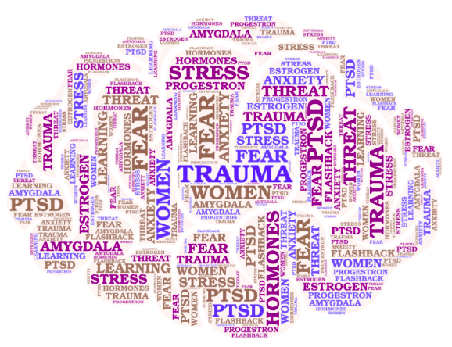Academic PI: Dr. Liat Halpman, Education Faculty, University of Haifa
Clinical PI: Dr Ayelet Eran, MRI unit, Rambam Medical Care Campus
Helsinki: 209-22-RMB
Summary: Following trauma, some women develop Post Traumatic Stress disorder (PTSD). The aim of the research is to identify the neural, hormonal, and cognitive mechanisms that are associated with the development of PTSD in women. The participants are community-dwelling women, 18 years and above, who experienced trauma.
MyTrial Israel, MOH_2021-01-24_009695
Status: Recruiting

Research/Ongoing projects/Elucidating the Neural Mechanisms of Expectancy-based Effects in Psychotherapy
Academic PI: Professor Sigal Zilca-Mano, School of Psychology, University of Haifa
Clinical PI: Dr Ayelet Eran, MRI unit, Rambam Medical Care Campus
Helsinki: 416-22-RMB
Summary: the study aims to test the efficacy of novel psychotherapy treatment for chronic depression and elucidate the neuro-cognitive networks that mediate this novel approach. Participants will be individuals who seek psychotherapy for depression symptoms and are willing to take part in psychotherapy sessions. The fMRI sessions are used as a measure of the intervention efficacy and for understanding the neural mechanism that underlies the psychotherapy rationale. The participants are community-dwelling adults, 18 years and above, who experience depression.
MyTrail Israel, MOH_2023-03-07_012403
Status: Recruiting

Research/Ongoing projects/The neural correlates of pain expectations and experience in individuals who suffer from Fibromyalgia: an fMRI study
Academic PI: Dr. Roee Admon, School of Psychology, University of Haifa
Clinical PI: Dr Ayelet Eran, MRI unit, Rambam Medical Care Campus
Helsinki: 425-22-RMB
Summary: Fibromyalgia is a chronic pain condition, characterised by pain flares. The study measures, physiological, behavioural, cognitive, emotional, and neuronal responses, with the aim to predict pain flares in participants who suffer from fibromyalgia. The participants are community-dwelling adults, 18 years and above.
MyTrail Israel, MOH_2023-03-06_012394
Status: Recruiting

Research/Ongoing projects/Characterization of cognitive biases and brain activity unique to symptoms of anxiety and depression
PI: Professor Hadas okonor-Singer, School of Psychology, University of Haifa
Clinical PI: Dr Ayelet Eran, MRI unit, Rambam Medical Care Campus
Helsinki: 0052-23-RMB
Summary: The current study aims to investigate the cognitive and neural processes that differentially characterise depression and anxiety symptoms. The participants are community-dwelling adults, 18 years and above.
MyTrail Israel, MOH_2023-10-25_013008
Status: Recruiting

Research/Ongoing projects/Neural correlates of extrinsic emotion regulation: an fMRI study
PI: Dr. Noga Cohen, School of Education, University of Haifa
Clinical PI: Dr Ayelet Eran, MRI unit, Rambam Medical Care Campus
Helsinki: 0291-23-RMB
Summary: The current study aims to increase the understanding of the ways emotional support offered to others ameliorates one’s own depression symptoms. This study specifically focuses on the underlying brain mechanisms. The participants will be community-dwelling adults, 18 years and above.
MyTrail Israel, MOH_2023-04-04_012503
Status: Recruiting

Be Part of Research
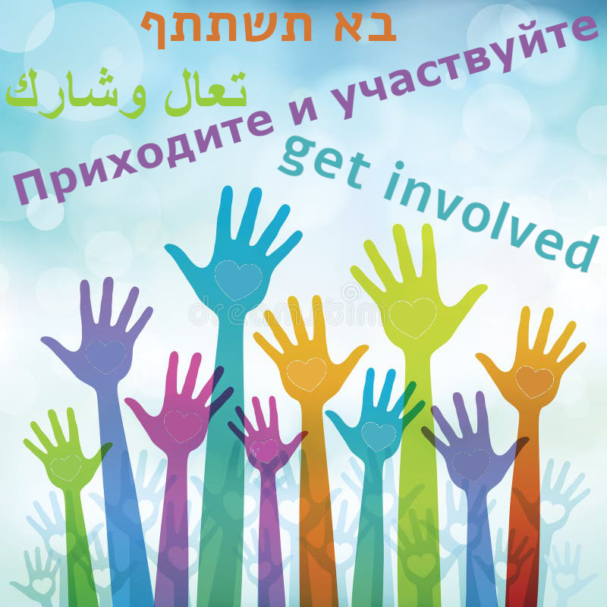

Volunteer to be a research participant
We always look for research participants. If you want to volunteer, please fill in the contact form, and we will contact you.
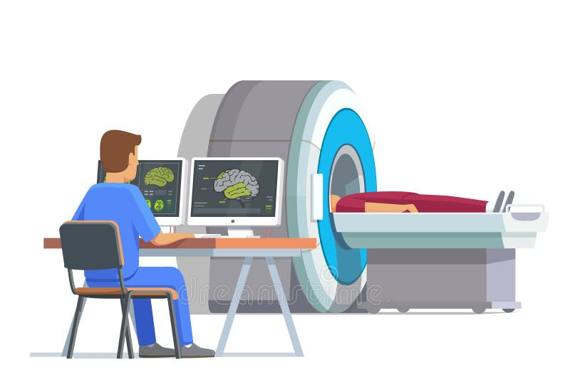

Who can volunteer for MRI research?
Anyone who does not have MR contra-indication. MRI is a very strong magnet. It is not safe to be close to a strong magnet if you have any metal in or on your body. To make sure that it is safe for you to go into the MRI scanner, we will typically ask you to fill out a metal-safety questionnaire. We will ask about:
- Your medical history, whether you were subjected to an invasive medical procedure, past injuries, or whether you have any implants (e.g. for cardio, hormonal, sugar levels).
- Whether you were involved in an accident.
- Whether you have any tattoos, piercings or permanent teeth retainers.
MRI can be a stressful experience for Individuals with claustrophobia. We do not allow pregnant women to take part in MRI research (unless it is specifically recruiting pregnant women), to avoid exposing the embryo to unknown risks.

Different studies will have additional exclusion and inclusion requirements for participation.

Volunteer to be part of a community-led research advisory board.
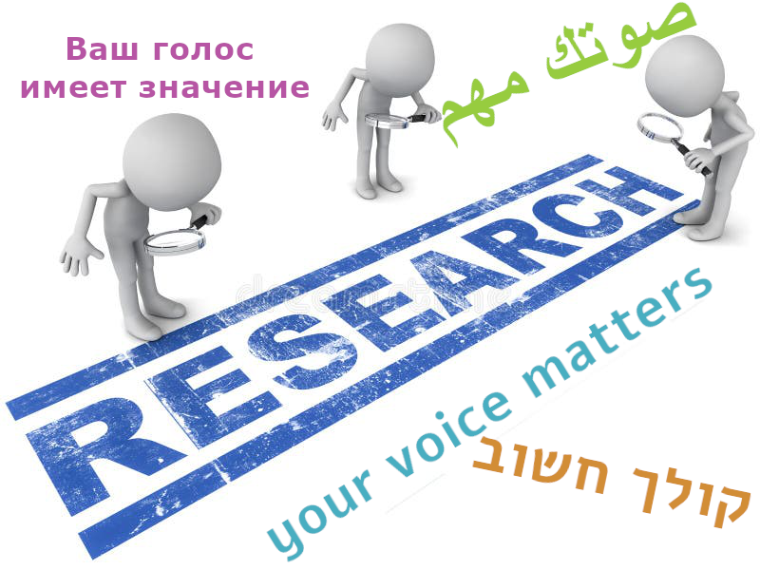
Most of our research is funded by the public for the benefit of the public. Therefore, we value the opinion of representative from the public as an important stake holder. We have a general community-led committee for advising on research project, and at time we establish a research specific committee.
What does it mean?
We will three meeting a year to discuss research and public involvement projects. We may also ask you 1-2 times per year to review research proposal written to the public. Participation is voluntary.
If you are interested in taking part in the community-led advisory board, please fill in the contact form.

Become research student.
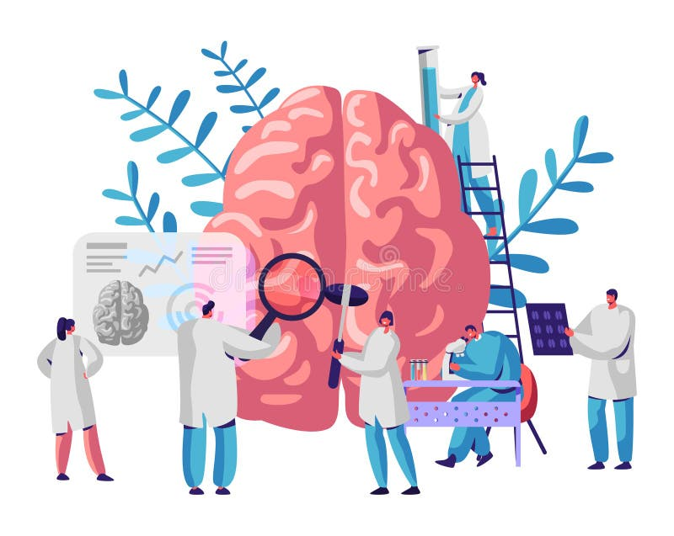
Undergraduate and postgraduate programs:
Haifa Brain and Behaviour Hub
Medical Imaging Sciences Department
Feel free to contact us for advice and guidance

Volunteer/become research assistant.

